Coordinated Access Lead HIFIS Manual
Last Update: Jan. 13, 2023

Introduction

This manual was developed to support the agency in each Saskatchewan Designated Community serving as the Coordinated Access Lead and their designated staff and includes the following information:
- List Inclusion Criteria
- List Data Points
- Generating the List
- Recording Matching & Referrals AND Returns to CA Regina
- Secure Management of the List
- Custom Reports for CE Reporting
- Frequently Asked Requestions

List Inclusion Criteria
The Prioritization List is a custom report developed for each HIPSK community to support the process of matching and referral. The By-Name List Coordinator is responsible for using the Prioritization List for their community to match and refer clients who are experiencing homelessness to a housing support that best meets their needs. The BNL Coordinator filters the Prioritization List to identify clients who meet the vacancy criteria (matching) and applies the prioritization policy to determine which of those clients will receive services first (prioritization).
The purpose of the Prioritization List is to identify clients and match and refer them to available inventory. As such, the List is designed to only include:
- clients who have indicated they are interested in receiving housing support services;
- clients who are in the community and positioned to accept a referral;
- clients who are actively experiencing homelessness.
The Prioritization List uses the real-time data entered into HIFIS to calculate who is included on the List. A client will ‘flow’ onto a community’s Prioritization List if all conditions in the table below are met:
Condition | Description
Consent Type = Coordinated Access + Explicit | The client is 16 or older and has consented to share their information and be added to the List.
Consent Status = Active | The client has an active consent in HIFIS.
Geographic Region (Vitals) = your community | The client has indicated they are interested in engaging in housing support services in your community.
Family Status = Family Head, Unaccompanied Youth, or Single | The client is either the head of the family or is accessing services on their own.
Activity Status = Active | The client has had a service-related transaction recorded in HIFIS within the last 90 days.
Housing Status = Homeless | The client is currently experiencing homelessness (currently the List includes clients in transitional housing).

List Data Points
The table below describes data points included on the Prioritization List and, where appropriate, how they are calculated. If a data point is included on a community’s List, an abbreviation will be included beside the data point (Regina = R; Prince Albert = PA).
Data Point | Description
Client ID^{(R+PA)} | A unique ID assigned to each client.
File Number^{(R+PA)} | Same as ID and can be used to search for a client.
Full Name^{(R+PA)} | Client Vitals
Alias^{(R+PA)} | Client Vitals
Consent Start^{(R+PA)} | Date most recent consent was given.
Consent Provider^{(R+PA)} | Provider most recent consent was collected by.
Last Activity^{(R+PA)} | Last activity recorded for the client in HIFIS.
Last Service Module^{(R+PA)} | Last place in HIFIS activity was recorded for the client.
Gender^{(R+PA)} | Client Vitals
DOB^{(R+PA)} | Client Vitals
Age^{(R+PA)} | Client Vitals
Veteran Status^{(R+PA)} | Client Vitals
Indigenous Status^{(R+PA)} | Client Vitals
Citizenship Status^{(R+PA)} | Client Vitals
Family Status^{(R+PA)} | Identifies client as Family Head, Unaccompanied Youth (24 and younger), or Single. Non-Family Head family members seeking housing services as a family are not listed separately.
Family Group ID^{(R+PA)} | N/A (will be removed in a future update).
Total Member^{(R+PA)} | Total number of family members, including the Family Head.
Members Under 16^{(R+PA)} | Total number of family members who are under the age of 16.
Last Known Housing Type^{(R+PA)} | Last housing type recorded (the record may be open or end dated).
Housing Status^{(R+PA)} | Housing status for the last known housing type. May be Homeless, Transitional, or Unknown. Clients with Unknown housing status do not have an open housing history record.
Mobility Issue^{(R+PA)} | Indicates if the client has a physical disability that would impact their housing needs.
Homelessness Total^{(R+PA)} | Total number of days homeless in lifetime.
Chronically Homeless^{(R+PA)} | Identifies if the client meets the federal definition of chronically homeless within a 1-year period.
Days Homeless 1Y^{(R+PA)} | Identifies the number of days homeless within 1 year.
Days Homeless 3Y^{(R+PA)} | Identifies the number of days homeless within 3 years.
Total Days Unsheltered^{(R+PA)} | Total days living unsheltered as calculated by the client’s housing history housing types.
Housing Search Date^{(R+PA)} | Date a Housing Placement was opened.
Housing Secured Date^{(R+PA)} | Date a housing unit was secured.
Expected Move In Date^{(R+PA)} | Date a move in is expected to the secured unit.
Housing Placement Status^{(R+PA)} | Status of the placement. May include:  - Housing Not Secured: indicates that the client is working with an agency to secure housing.  - Housing Secured: Indicates that the client has secured housing and a move-in is anticipated.  - Moved In House: Indicates that the client has moved in to housing (NOTE: this will only populate on the list if the client was moved into Transitional Housing).  - Follow-up Complete: Indicates that the client has returned to homelessness after previously working with another agency and moving into housing.
Status^{(R+PA)} | Active = client has an open housing placement (working with agency to find housing)  Inactive = client does not have an open housing placement (is not working with an agency)
Housing Placement Provider^{(R+PA)} | Indicates the agency the client is currently working with to find housing.
Expecting ^{(PA)} | Y or N value calculated from PA Expecting survey to indicate if a client is pregnant.
Substance Use ^{(PA)} | Score (1-4) calculated from PA Intake Assessment survey.
Assessment Date ^{(PA)} | Date last PA Intake Assessment survey was performed.
Assessment Score ^{(PA)} | Total score of last PA Intake Assessment survey performed.
TriMorbidity^{(R)} | Calculates from 3 SPDAT question scores.
Dep or Preg^{(R)} | Calculates from 1 pre-assessment question (recorded as a survey).
SPDAT Intake Date & Time^{(R)} | When the SPDAT was taken.
SPDAT Intake Type^{(R)} | Type of SPDAT taken.
SPDAT Intake Score^{(R)} | SPDAT Score (of last SPDAT taken).
Days since inflow^{(R+PA)} | Days since most recent inflow onto the list.

Generating the List

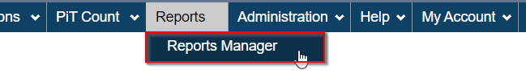
- From the horizontal menu, select Reports > Reports Manager.

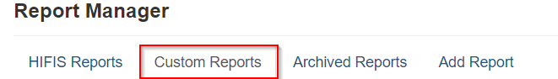
- Select the Custom Reports tab.
- Locate the report for your community based on the naming conventions below. If desired, locate the report by typing the report name into the Filter items box.
- Regina Prioritization List
- Prince Albert Prioritization List
- Saskatoon Prioritization List
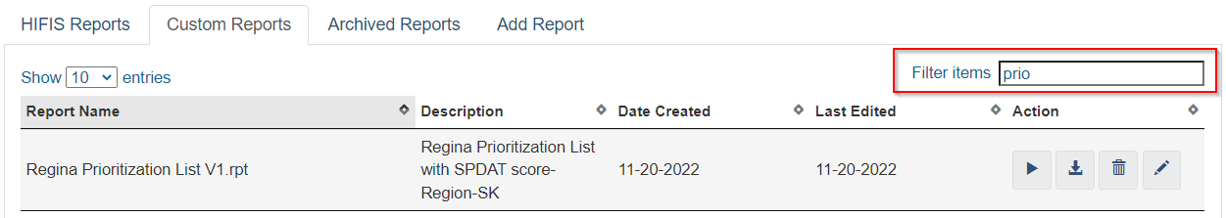

- Click the Run Report button under the Action column.

- Click the Export this Report button.

- Select the File Format Microsoft Excel (97-2003) Data-Only and click Export.

- The file will download to the bottom of your browser. Click on the file to open the report.

- Click Enable Editing to work with the report.

- To add filters to the report, row 1. On the menu, select Data > Filter.
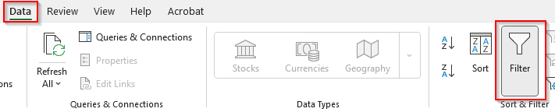

Recording CA Regina Matching & Referrals AND Returns to CA Regina ^{(R)}
Express Services in HIFIS is used by the Regina BNL Coordinator to record the following:
- Clients who were matched and referred to an agency for services; and
- Clients who were returned by an agency to CAR because they could not be contacted/found.

Recording CAR Referrals
Follow the instructions below to record a referral:
- Select Front Desk > Goods and Services
- Click on the Express Service button
- Populate the record as described below:
  - Client Name(s) = enter the name of the Client you referred out
  - Service = CAR Referral
  - Program = RH-Funded (automatically selected); Priority Category based on SPDAT score
  - Reason for Services = Coordinated Access
  - Expended hours & minutes = identify the amount of time involved in the process; if multiple clients are selected, indicate approximately how much was spent per client rather than the total time.
  - Referred to = select the agency you referred out to
  - Comments = as appropriate
NOTE: Since there is no date field on the Express Service screen, referrals MUST be recorded in HIFIS the same day they are made.

Recording Returns to CAR
Follow the instructions below to record a return to CAR.
- Select Front Desk > Goods and Services
- Click on the Express Service button
- Populate the record as described below:
  - Client Name(s) = enter the name of the Client being returned
  - Service = CAR Return
  - Program = RH-Funded (automatically selected); Priority Category based on SPDAT score
  - Reason for Services = Client not Found; Client Refused Services; Client not Servable; Out of scope
  - Expended hours & minutes = indicate the amount of time involved in the process of locating the client, if disclosed by the agency.
  - Referred to = select the agency who returned the client
  - Comments = as appropriate

Secure Management of the List
The BNL Coordinator is responsible for ensuring that List and other data exported from HIFIS is securely stored and kept private.
- Only access HIFIS from an approved work device and site;
- Do not electronically transmit information that identifies clients by name;
- Do not print out/hand out copies of the Prioritization List when Case Conferencing – if matching and referral occurs in real time, consider projecting the List for approved attendees to view as a group.
- Do not share client names with the CE. Instead, use the Client’s ID number.

Custom Reports for CE Reporting
Custom reports can be requested from the HIFIS Team as needed. Completed and submit a Custom HIFIS Report Request Form to request a report. This form is available at the HIFIS Support Centre.
The list below includes reports custom-built to meet Regina’s reporting and CA oversight needs.
Placement Activity Status - Regina RH Funded Agencies ^{(R)}
Client ID and Status columns from the community’s Prioritization List, with totals for total of open Housing Placements, and the number that are Active (Open) and Inactive (Closed or never opened).

Placement Move Ins - Regina RH Funded Agencies ^{(R)}
Totals for the number of Family Heads, Unaccompanied Youth, and Singles who have had a Housing Placement opened and had a Moved In recorded.

Placement Status (Housed vs. Not Housed) - Regina RH Funded Agencies ^{(R)} (PENDING)
Total number of clients with Geographic Region for community with an open housing placement at the time the report was generated, and a breakdown of that total into Status categories: moved into housing, housing secured, or housing not secured.
Referrals vs. Placements - Regina RH Funded Agencies ^{(R)} (PENDING)
This report compares Housing Placements to referrals per client and is organized by Regina RH Funded agencies. This report will have three columns:
- Column 1: Client ID;
- Column 2: Matched & Referred Date (this is recorded by CAR as an Express Service for the client;
- Column 3: Housing Placement Search Started Date.

Referrals ^{(R)} (PENDING)
This report lists the SPDAT score for clients, where they were referred to and when, and includes the following:
- Client ID
- SPDAT Score
- Referred to Agency
- Date of Referral

CAR Referrals and Returns ^{(R)} (PENDING)
A list of clients CAR has recorded as being Matched & Referred and, where applicable, to being returned, with a date included.

HIFIS Report FAQs

- How do I filter the List to identify only clients who are unhoused and unconnected to an agency?
  - Filter the Status column to display clients with an Inactive value.

- How do I filter the List to identify clients who are unhoused but connected to an agency, and how do I sort this by agency?
- Filter the Status column to display clients with an Active value.
- Filter the Housing Placement Provider column A to Z OR select the agencies you want to display.
- People who are housed and connected to an agency (sorted by agency).
  - Run one of the following custom reports:
    - Placement Move Ins - Regina RH Funded Agencies
    - Placement Status (Housed vs. Not Housed) - Regina RH Funded Agencies (PENDING)
    - Housing Placements By Service Provider - Regina RH Funded Agencies

